**Example: Shortest Path for Messaging**

The mobile social network among students in MGT 40750 is provided in the following diagram,  
where ● represents Female and ■ represents Male.

Question: Find the shortest path from Node 42 to Node 9 through this mobile social network.

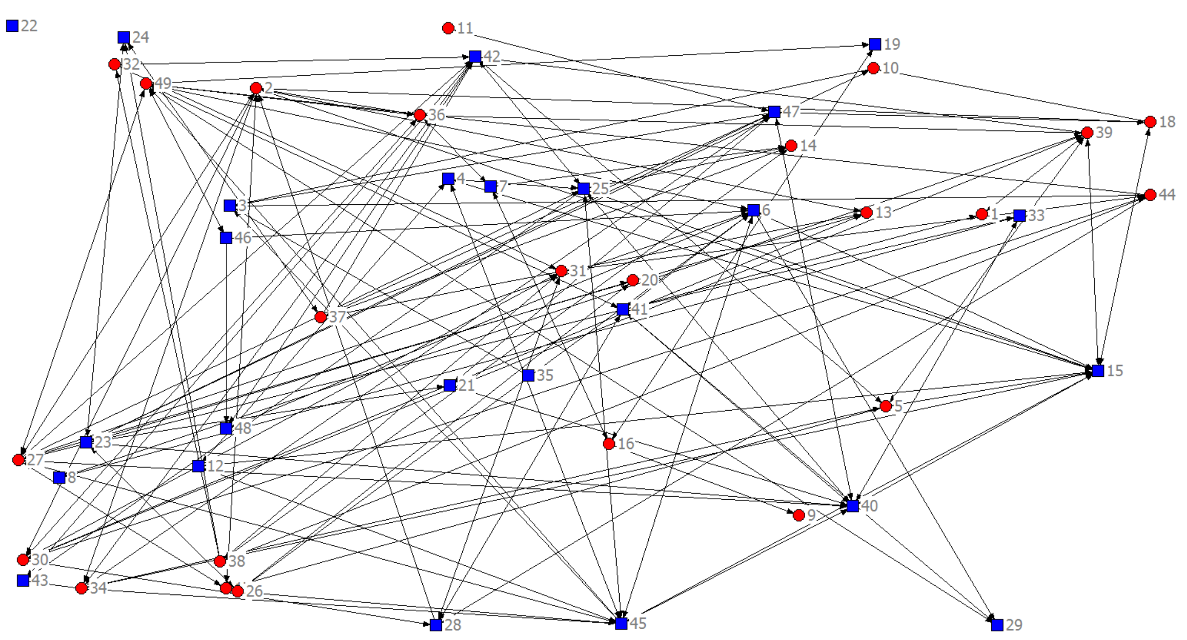

**Shortest Path for Messaging**

**Set up the Shorted Path for Messaging model in Excel: (Start = 42 End = 9)**

|  |
| --- |
| -1  1  =sum(D5:D195)  =sumif(A$5:A$195,F6,D$5:D$195) - sumif(B$5:B$195,F6,D$5:D$195) |
| … |
|  |

**Specify Solver:**

Set Objective: L5

To: ○ Max X Min ○ Value of: _________

By Changing Variable Cells: D5:D195

Subject to the Constraints:

|  |
| --- |
| G5:G54 = I6:I54  D5:D195 = Integer |

X Make Unconstrained Variables Non-Negative

Select a Solving Method: Simplex LP

**Solver Results:**

7 🡪 16

14 🡪 7

16 🡪 9

25 🡪 14

42 🡪 25

Thus, the shortest path is 42 🡪 25 🡪 14 🡪 7 🡪 16 🡪 9.

The optimal total distance = 5.